Volatility Estimator

The following contents were taken from websites such as Investopedia, in order to provide users with an overview of what are some common volatility measures that firms employ in assessing risk.

- https://www.investopedia.com/investing/understanding-volatility-measurements/
- https://www.ig.com/sg/trading-strategies/are-these-the-8-best-volatility-indicators-traders-should-know--230124
- https://medium.com/@gianlucabaglini/estimate-volatility-with-sma-and-ewma-in-python-744094730150

Introduction

When considering the volatility of funds, an investor may find it difficult to decide which will provide the optimal risk-reward combination. Understanding volatility is key, and while many websites provide various volatility measures for mutual funds free of charge, it can be hard to know what the figures mean and how to analyze them.

The relationship between these figures is not always obvious. The first section will cover the four most common volatility measures: standard deviation, beta, R-squared, and alpha. Find out how they are applied and use them to make informed investment decisions and optimize your portfolio.

Understanding Standard Deviation in Volatility Assessment

The standard deviation essentially reports a fund's volatility, which indicates the tendency of the returns to rise or fall drastically in a short period of time. A volatile security is also considered a higher risk because its performance may change quickly in either direction at any moment. The standard deviation of a fund measures this risk by measuring the degree to which the fund fluctuates in relation to its mean return. This can be represented with the Mathematical formula as follow:

$$σ_{T}=σ\sqrt{T}$$
- $σ_{T}$: Volatility over a time horizon
- $σ$: Standard Deviation of returns
- $T$: Number of periods in a time horizon

The standard deviation of returns can be computed as follow:

$$σ=\sqrt{\frac{\sum{{\left(x_{i}-μ\right)}^{2}}}{N}}$$
- $x_{i}$: Daily price of the asset
- $σ$: Standard Deviation
- $N$: Number of periods / trading days
- $μ$: Mean of prices

As volatility is only one indicator of the risk affecting a security, a stable past performance of a fund is not necessarily a guarantee of future stability. Since unforeseen market factors can influence the volatility, a fund with a standard deviation close or equal to zero this year may behave differently the following year.

To determine how well a fund is maximizing the return received for its volatility, you can compare the fund to another with a similar investment strategy and similar returns. The fund with the lower standard deviation would be more optimal because it is maximizing the return received for the amount of risk acquired.

Measuring Market Volatility with Beta

While standard deviation determines the volatility of a fund according to the disparity of its returns over a period of time, beta, another useful statistical measure, compares the volatility (or risk) of a fund to its index or benchmark. A fund with a beta very close to one means the fund's performance closely matches the index or benchmark. A beta greater than one indicates greater volatility than the overall market, and a beta less than one indicates less volatility than the benchmark. The formula for Beta can be expressed as follow:

$$β_{p}=\frac{Corr(r_{m}, r_{p})}{Var(r_{m})}$$
- $r_{m}$: Market returns
- $r_{p}$: Portfolio / Asset returns

If, for example, a fund has a beta of 1.05 in relation to the S&P 500, the fund has been moving 5% more than the index. Therefore, if the S&P 500 increased by 15%, the fund would be expected to increase by 15.75%. On the other hand, a fund with a beta of 2.4 would be expected to move 2.4 times more than its corresponding index. So if the S&P 500 moved 10%, the fund would be expected to rise 24%, and if the S&P 500 declined 10%, the fund would be expected to lose 24%.

Investors expecting the market to be bullish may choose funds exhibiting high betas, which increases the investors' chances of beating the market. If an investor expects the market to be bearish in the near future, the funds with betas less than one are a good choice because they would be expected to decline less in value than the index. For example, if a fund had a beta of 0.5, and the S&P 500 declined by 6%, the fund would be expected to decline only 3% Beta by itself is limited and can be skewed due to factors other than the market risk affecting the fund's volatility.

The Role of R-Squared in Volatility Analysis

The R-squared of a fund shows investors if the beta of a mutual fund is measured against an appropriate benchmark. Measuring the correlation of a fund's movements to that of an index, R-squared describes the level of association between the fund's volatility and market risk, or, more specifically, the degree to which a fund's volatility is a result of the day-to-day fluctuations experienced by the overall market.

R-squared values range between 0 and 100, where 0 represents the least correlation, and 100 represents full correlation. If a fund's beta has an R-squared value close to 100, the beta of the fund should be trusted. On the other hand, an R-squared value close to 0 indicates the beta is not particularly useful because the fund is being compared against an inappropriate benchmark.

If, for example, a bond fund was judged against the S&P 500, the R-squared value would be very low. A bond index such as the Bloomberg US Aggregate Bond Index would be a much more appropriate benchmark for a bond fund so that the resulting R-squared value would be higher. Obviously, the risks apparent in the stock market are different than those associated with the bond market. Therefore, if the beta for a bond were calculated using a stock index, the beta would not be trustworthy.

An inappropriate benchmark will skew more than just beta. Alpha is calculated using beta, so if the R-squared value of a fund is low, it is also wise not to trust the figure given for alpha.

Evaluating Fund Performance with Alpha

So far, we covered how to examine figures measuring risk posed by volatility, but how do we measure the extra return rewarded to you for taking on the risk posed by factors other than market volatility? Enter alpha, which measures how much if any of this extra risk helped the fund outperform its corresponding benchmark. Using beta, alpha's computation compares the fund's performance to that of the benchmark's risk-adjusted returns and establishes if the fund outperformed the market, given the same amount of risk. We can represent Alpha with the CAPM model as follow:

$$α=r_{p}-\left[r_{f}+ β(r_{m}-r_{f})\right]$$

Most of the time we would just assume the risk-free rate of return to be 0, so we can simplify the expression above to the following:

$$α=r_{p}-βr_{m}$$

By rearranging the above, we can express it as follow:

$$r_{p}= βr_{m}+ α or E\left(r_{p}\right)= βE\left(r_{m}\right)+α+ε$$

Which is an OLS regression of our portfolio / asset returns against the benchmark.

For example, if a fund has an alpha of one, it means that the fund outperformed the benchmark by 1%. Negative alphas are bad in that they indicate the fund underperformed for the amount of extra, fund-specific risk the fund's investors undertook.

Other Critical Volatility Indicators

Apart from the above four estimators (standard deviation, beta, R-squared, and alpha), there are other useful measures that one can use for assessing the volatility of an asset / portfolio.

1. Bollinger Bands

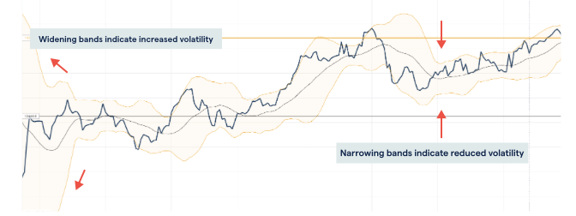

Bollinger Bands are a prominent type of technical price indicator. An upper and lower band, placed on either side of a simple moving average (SMA), make up their structure. Each band can be used to identify regions of support and resistance because it is plotted two standard deviations from the market's SMA.

Strong trends produce volatility, which is seen when the Bollinger Bands widen and narrow, making them valuable trend indicators.

2. Average True Range (ATR)

The Average True Range (ATR) indicator is used to track volatility over a given period of time. It moves upward or downward based on how pronounced price changes are for an asset, with a higher ATR value indicating greater market volatility and a lower ATR indicating lower market volatility.

To calculate the average true range, you first need to calculate the true range. You do this by taking the largest of these three calculations:
- The current high minus the previous close
- The current low minus the previous close
- The current high minus the current low

We can think of it as follow:

$$\max\left(H_{t}-C_{t-1},L_{t}-C_{t-1}, H_{t}-L_{t}\right)$$

You could repeat this process over a specific timeframe to get a moving average of a series of true ranges.
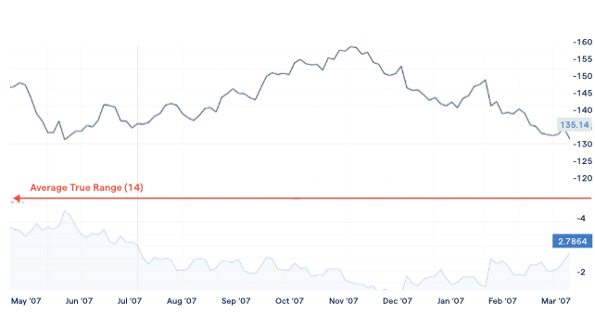

ATR is a smoothed moving average of volatility over a given time frame, and is often used for assessing when and where to enter or exit a position, as well as at what price level to implement a trailing or guaranteed stop

Project: Volatility Estimator

We will build a tool that computes and compare different volatility measures on the same asset. Start with simple historical volatility using log returns and then add rolling windows (20, 60, 120 days) and an EWMA version to capture recent shocks faster. Extend it by comparing realized volatility before and after macro events like CPI or CB meetings

Aim of project: Show that you understand volatility as a dynamic risk metric and not just a formula

1. Baseline / Foundational Volatility Measures

a. Historical Volatility (Close-to-Close): Standard deviation of log returns

$$r_{t}=ln⁡\left(\frac{P_{t}}{P_{t-1}}\right)$$
$$σ=\sqrt{\frac{1}{N-1}∑(r_{t}-\overset{ˉ}{r})^{2}}$$

b. Rolling Historical Volatility: Compute historical volatility over rolling windows:
- 20 days (≈ 1 month)
- 60 days (≈ 3 months)
- 120 days (≈ 6 months)

2. Exponentially Weighted Measures (Faster Reaction)

a. EWMA Volatility (RiskMetrics-Style)

$$σ_{t}^{2}=λσ_{t-1}^{2}+(1-λ)r_{t}^{2}$$
Common λ values:
- 0.94 (daily equities)
- 0.97–0.99 (macro / rates)

b. EWMA with Event Reset (Advanced)
- Reset or partially reset variance around macro events
- Useful for CPI / FOMC / ECB days

3. Realized Volatility (Higher-Fidelity)

a. Realized Volatility (Intraday-Based): If intraday data is available

$$RV=\sum_{i=1}^{n}{r_{t,i}^{2}}$$
Variants
- 5-minute returns (common)
- Subsampled RV to reduce microstructure noise

b. Event-Window Realized Volatility

Compute realized volatility:
- Before event (e.g. −5 to −1 days)
- After event (+1 to +5 days)

